Stone Barrett

Assignment 04

7/14/19

**Problem 1: Utilities**

Screenshots of the code:

For this first problem, understanding how inheritance in Java works was crucial. I needed to make each of the four classes do exactly what they needed and to work well with each other. Each of the Gas and Electric classes contained the variables required as well as a method to calculate bills. The Utility class is the parent class of those two and contains what they need to inherit. The main function lies in the Collection class and it’s there that the array is set up and the information is printed back to a user. Unfortunately, as you can see in the output screenshot below, there was an error that I could not resolve in time. I had a few other students look and try to figure out the problem, and I gathered that my sorting method didn’t work with the information I passed to it.

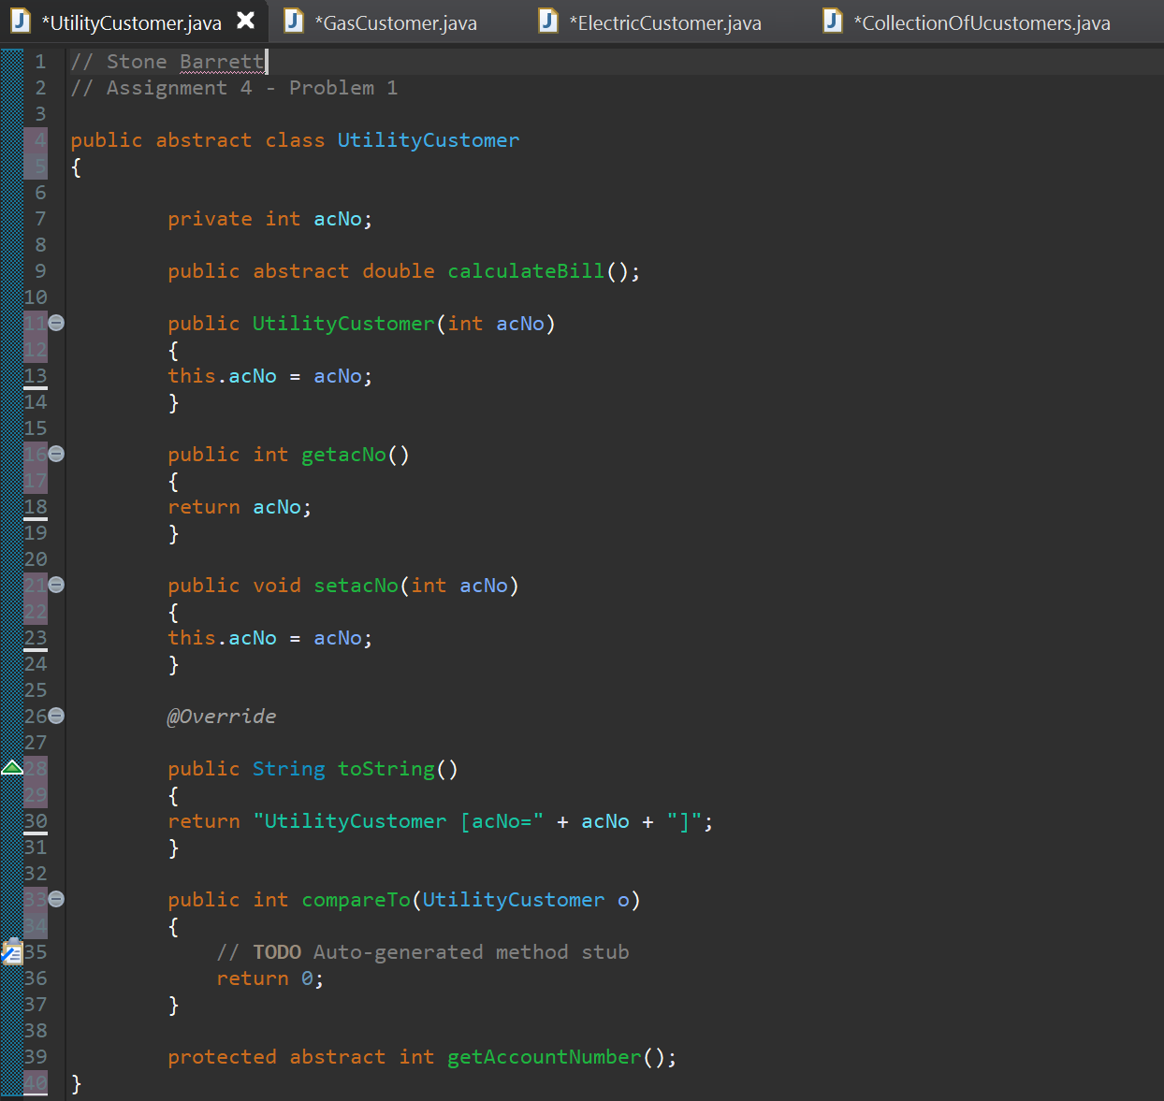

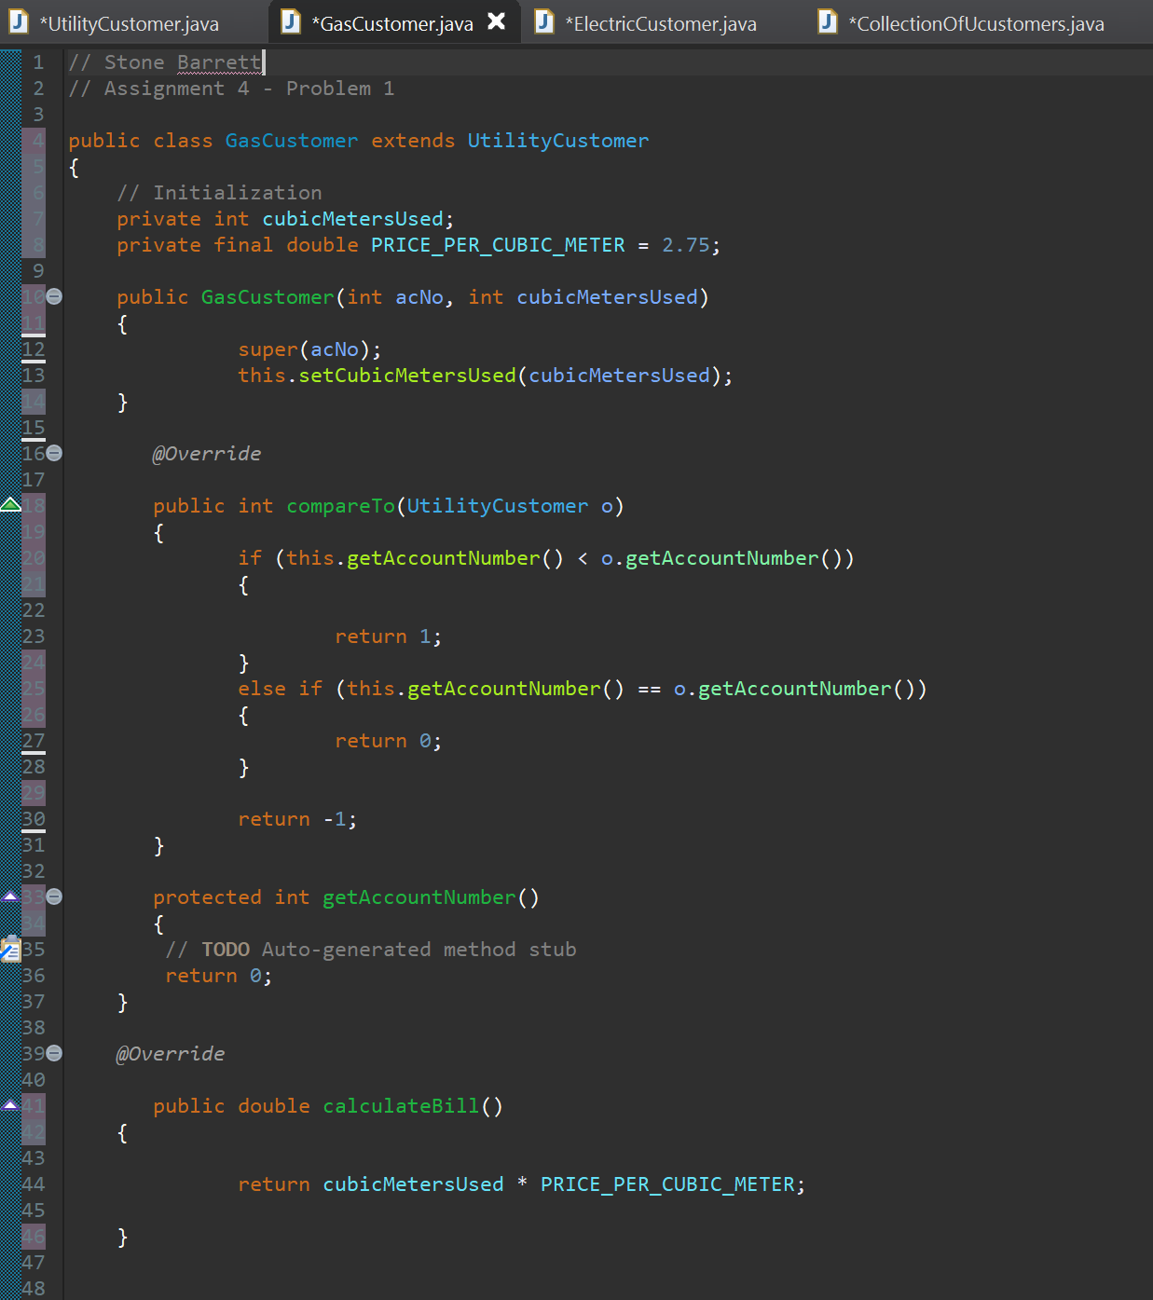

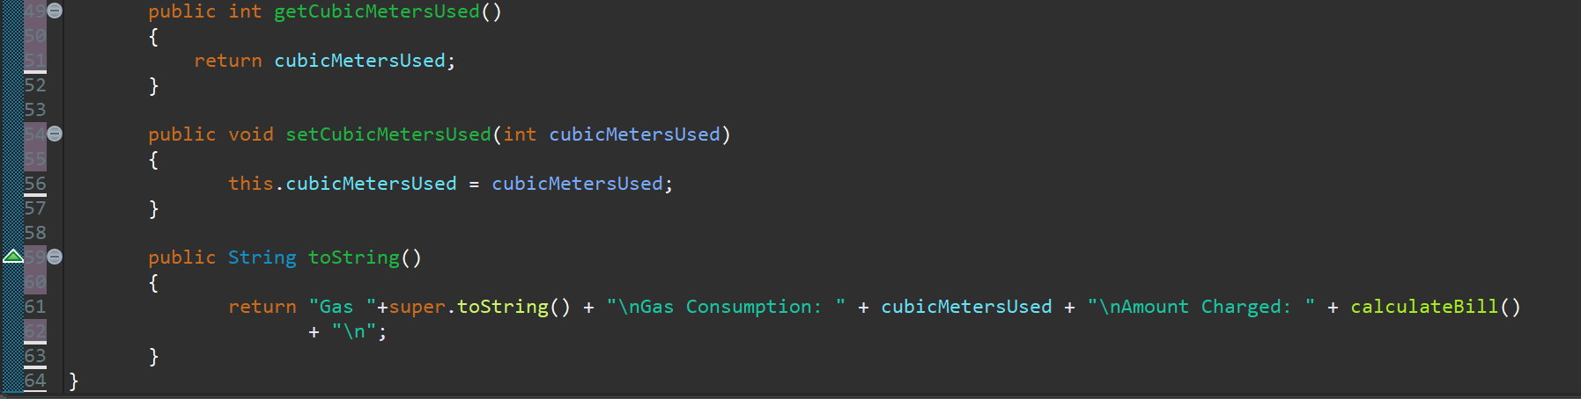

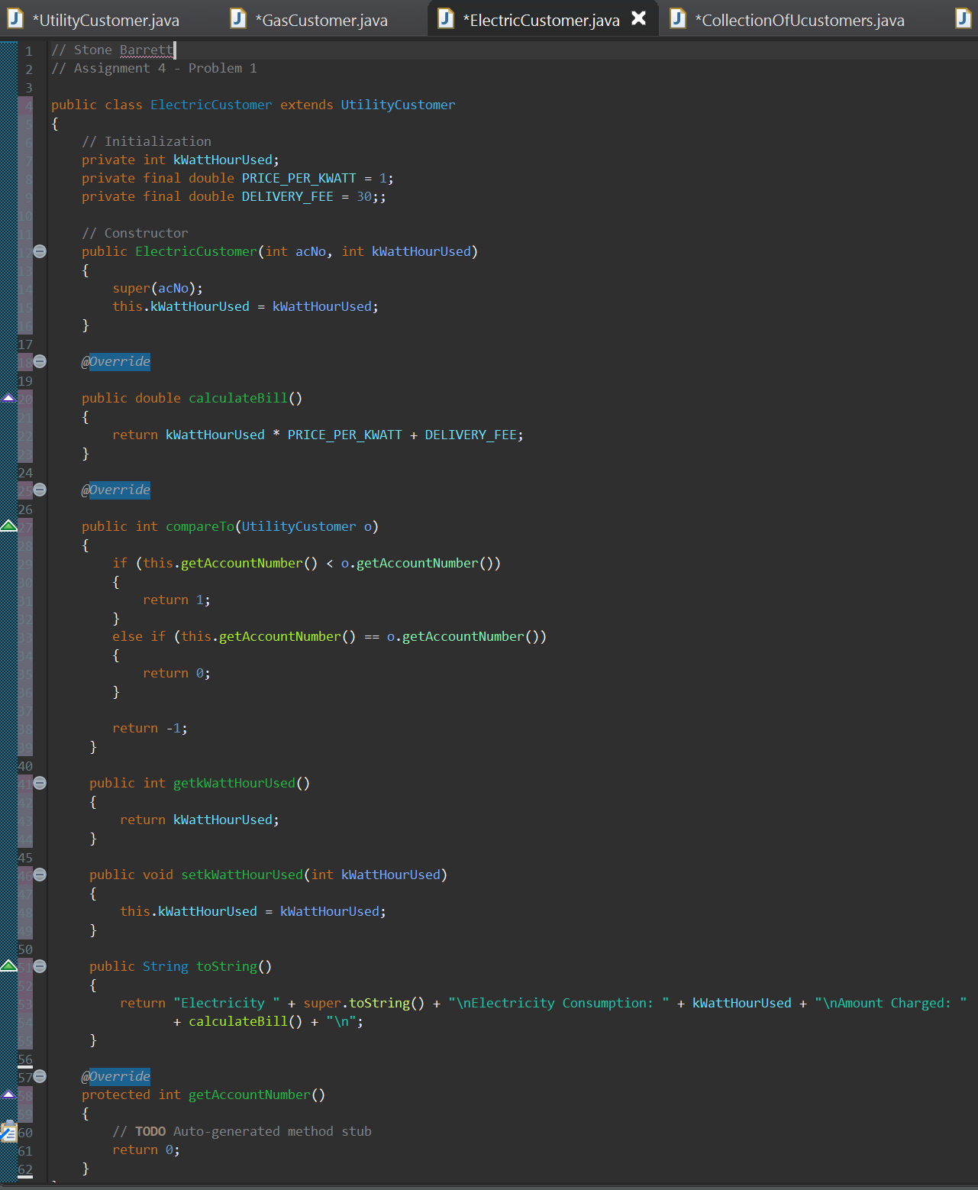

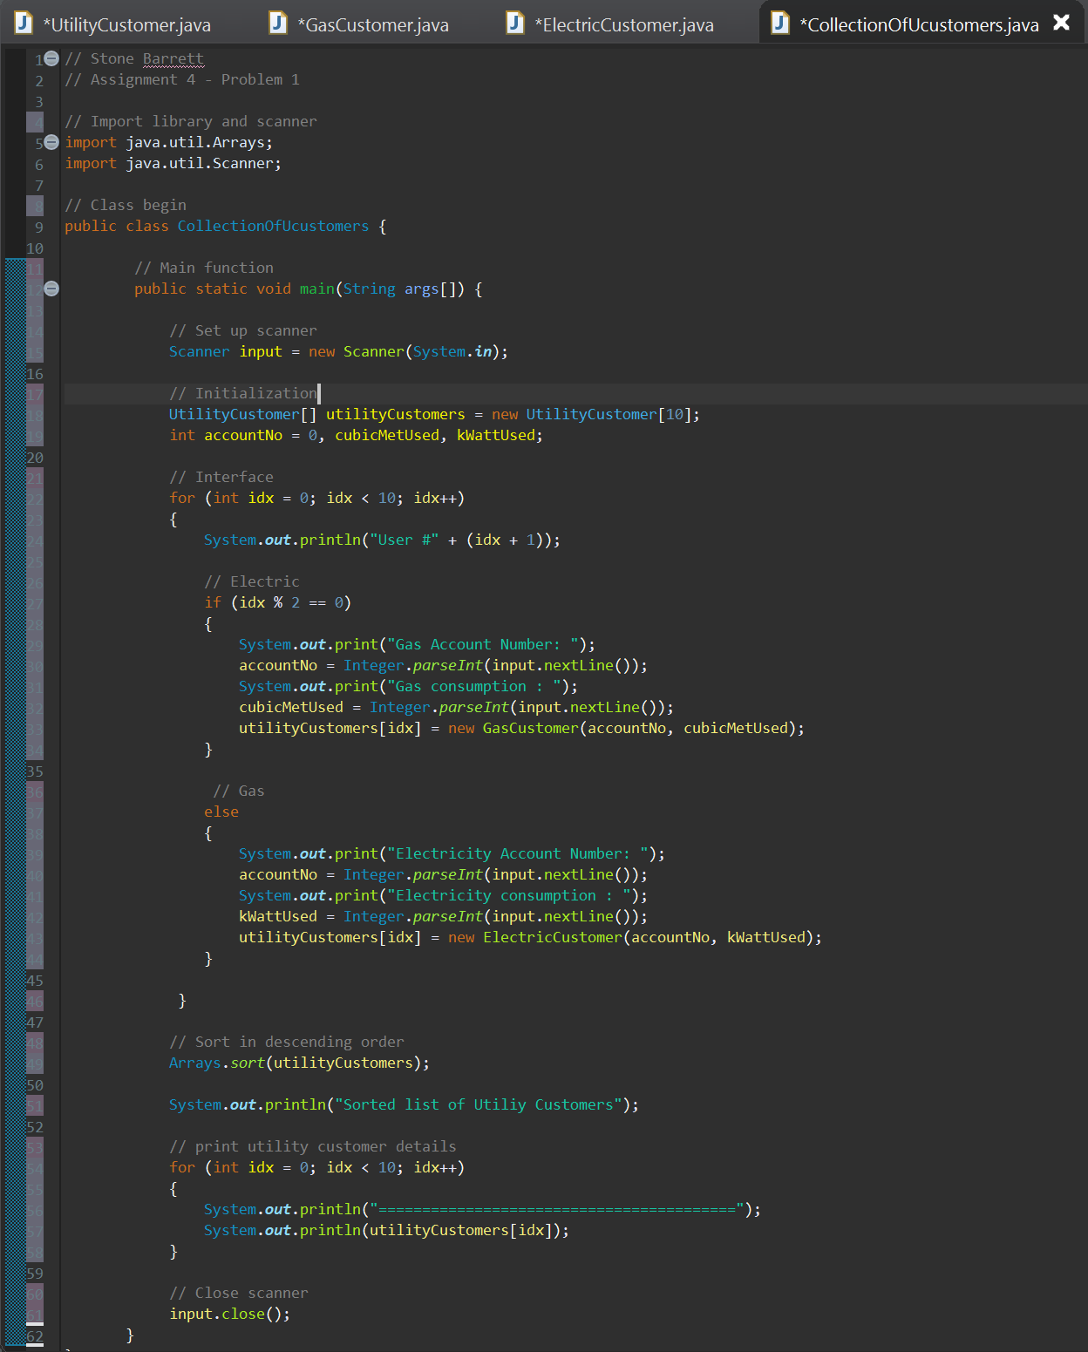

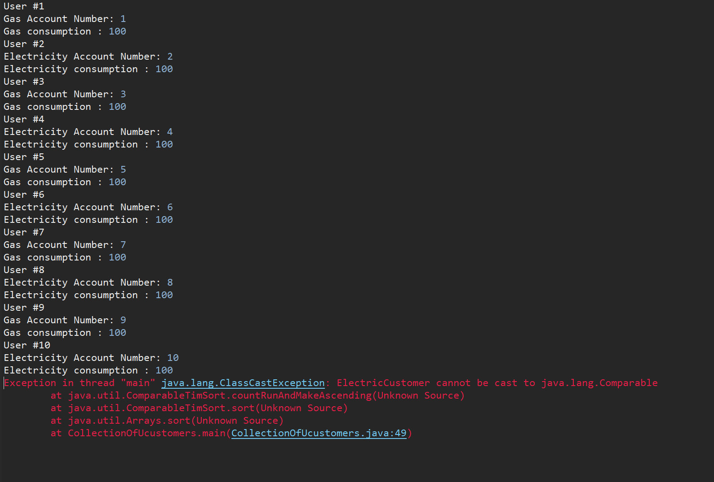

**Problem 2: Tip**

This problem I considered to be more interesting that the first. Also, I like JavaFX but before doing anything I needed to allow access to the correct libraries within the build path of the project file. I imported all the libraries I needed and set up the grid pane. I decided to use radio buttons instead of a drop-down menu. I added a text field to enter the meal price. The four options for tip percentages are there for one to be selected. After this, the sales tax is set to 8% and all of the price is calculated and reported back to the user.

Screenshots of the code:

